**Term work**

**on**

**Full Stack Web**

**Development**

**(PCS 693)**

**2023**

**Submitted to: Submitted by:**

Mr. Animesh Srivastava Amandeep Singh

Assistant Professor University Roll. No.:2018143 GEHU, Dehradun Class Roll. No./Section: 09/E

**DEPARTMENT OF COMPUTER SCIENCE AND ENGINEERING**

**GRAPHIC ERA HILL UNIVERSITY, DEHRADUN**

**ACKNOWLEDGMENT**

I would like to particularly thank my Full Stack Web Development Lab Faculty

**Mr. Animesh Srivastava** for his patience, support and encouragement throughout the completion of this Term work.

At last but not the least I greatly indebted to all other persons who directly or indirectly helped me during this course.

**Amandeep Singh**

**University. Roll No.- 2018143**

**B.Tech CSE-E-VI Sem**

**Session: 2023**

**GEHU, Dehradun**



**DEPARTMENT OF CSE STUDENT LAB REPORT SHEET**

Photograph Passport Size

**Name of Student:** …………………………………………… **Mob. No.:** …………………………….

**Address**: ……………………………………………………………………………………………………………

**Father’s Name:** ……………………………………… **Occupation:** …………………………………….

**Mob. No.:** ……………………………………….

**Mother’s Name:** ……………………………………. **Occupation:** …………………………………….

**Section:** …….. **Branch:** ……….. **Semester:** ……. **Class Roll No.:** ……. **Grade: A B C Email:** ……………………………………………………………… **Marks: 5 3 1**

|  |  |  |  |  |  |  |  |  |
| --- | --- | --- | --- | --- | --- | --- | --- | --- |
| **S.No.** | **Practical** | **D.O.P.** | **Date of Submission** | **Grade (Viva)** | **Grade (Report File)** | **Total Marks (out of**  **10)** | **Student’s Signature** | **Teacher’s Signature** |
| **1** | **Practical-01** |  |  |  |  |  |  |  |
| **2** | **Practical-02** |  |  |  |  |  |  |  |
| **3** | **Practical-03** |  |  |  |  |  |  |  |
| **4** | **Practical-04** |  |  |  |  |  |  |  |
| **5** | **Practical-05** |  |  |  |  |  |  |  |
| **6** | **Practical-06** |  |  |  |  |  |  |  |
| **7** | **Practical-07** |  |  |  |  |  |  |  |
| **8** | **Practical-08** |  |  |  |  |  |  |  |
| **9** | **Practical-09** |  |  |  |  |  |  |  |
| **10** | **Practical-10** |  |  |  |  |  |  |  |

|  |  |  |  |  |  |  |  |  |
| --- | --- | --- | --- | --- | --- | --- | --- | --- |
| **11** | **Practical-11** |  |  |  |  |  |  |  |
| **12** | **Practical-12** |  |  |  |  |  |  |  |
| **13** | **Practical-13** |  |  |  |  |  |  |  |
| **14** | **Practical-14** |  |  |  |  |  |  |  |
| **15** | **Practical-15** |  |  |  |  |  |  |  |
| **16** | **Practical-15** |  |  |  |  |  |  |  |
| **17** | **Practical-15** |  |  |  |  |  |  |  |
| **18** | **Practical-18** |  |  |  |  |  |  |  |

**Total No of Practical allotted …………………………………**

**Total No of Practical completed ………………………………….**

**Percentage Attendance of Practical …………………………….**

**Practical 1**

1. **Design a page having suitable background colour and text colour with title “My First Web Page” using all the attributes of the Font tag.**

<!DOCTYPE html>

<html lang="en">

<head>

<title>First Web Page</title>

</head>

<body style="background-color: cyan;">

<font size="10" color="red" face="Verdana">My First Web Page</font>

</body>

</html>

**Output**

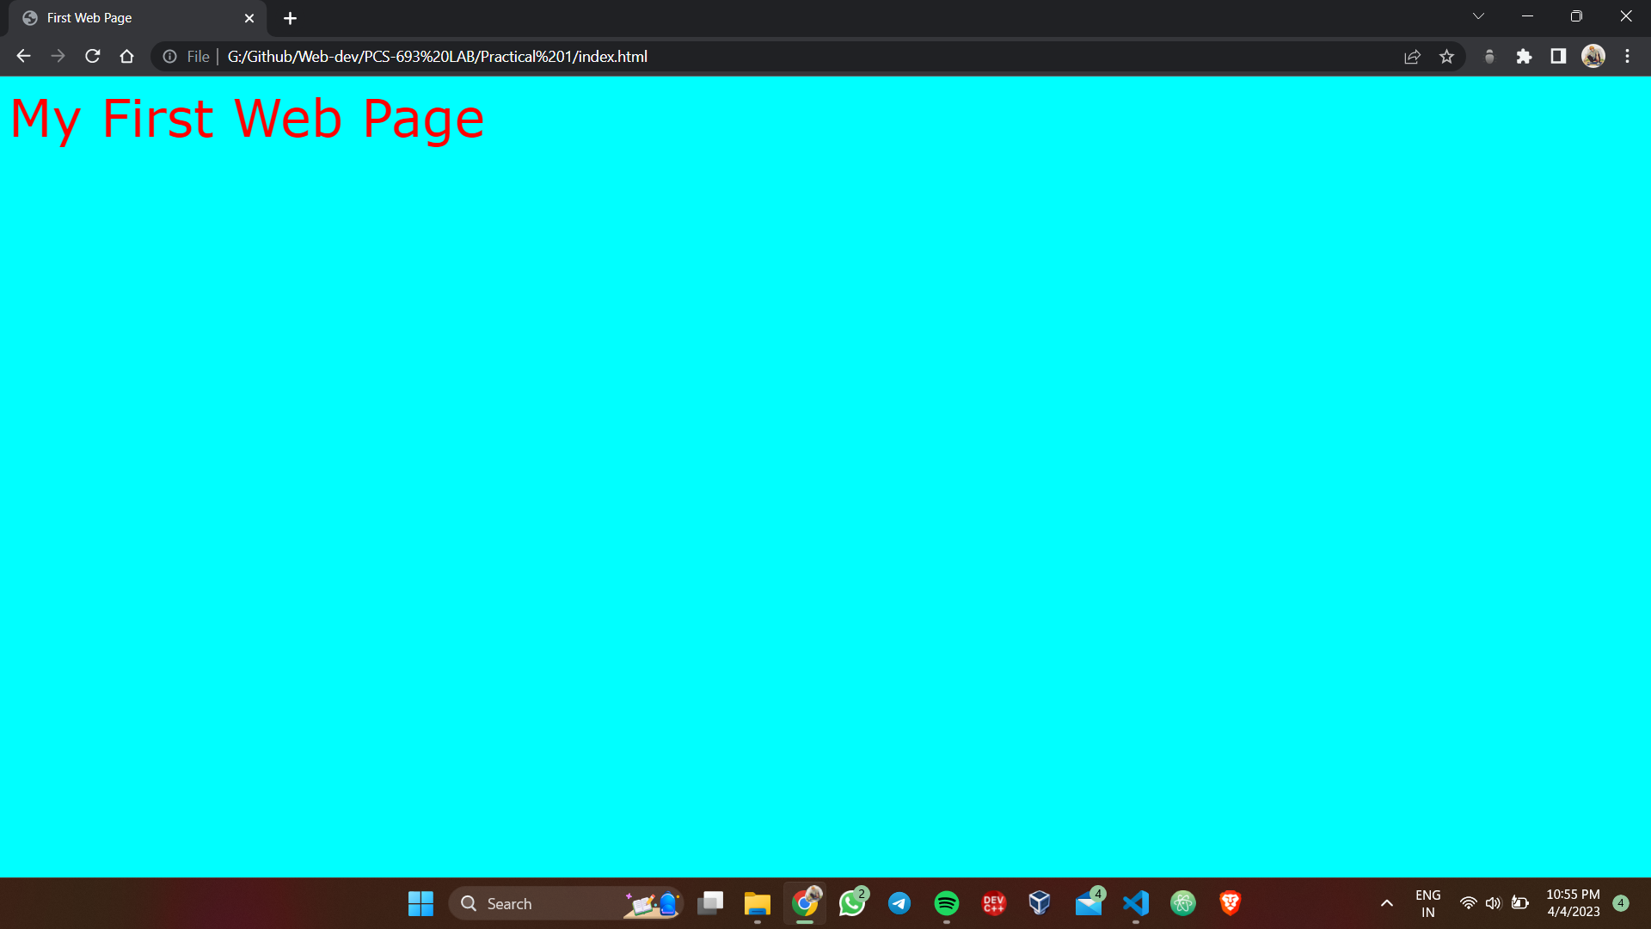

**Practical 2**

1. **Write HTML code to design a page containing some text in a paragraph by giving suitable heading style.**

<!DOCTYPE html>

<html lang="en">

<head>

<title>Headed Paragraph</title>

</head>

<body>

<h1><p>Heading 1</p></h1>

<h2><p>Heading 2</p></h2>

<h3><p>Heading 3</p></h3>

<h4><p>Heading 4</p></h4>

<h5><p>Heading 5</p></h5>

<h6><p>Heading 6</p></h6>

</body>

</html>

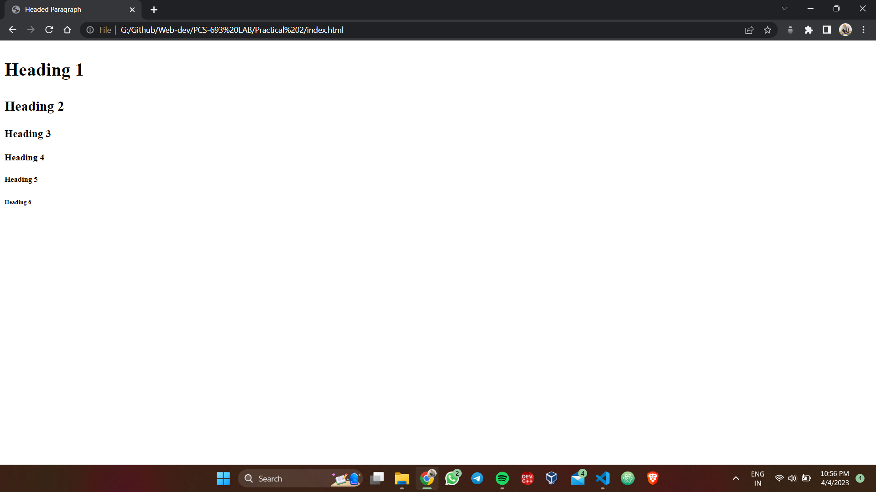**Output**

**Practical 3**

1. **Write HTML code to create a Web Page that contains an Image at its centre.**

<!DOCTYPE html>

<html lang="en">

<head>

<title>Centered Image</title>

</head>

<body>

<img src="myImage.png" alt="" style="display:block; width:50%; margin: auto;">

</body>

</html>

**Output**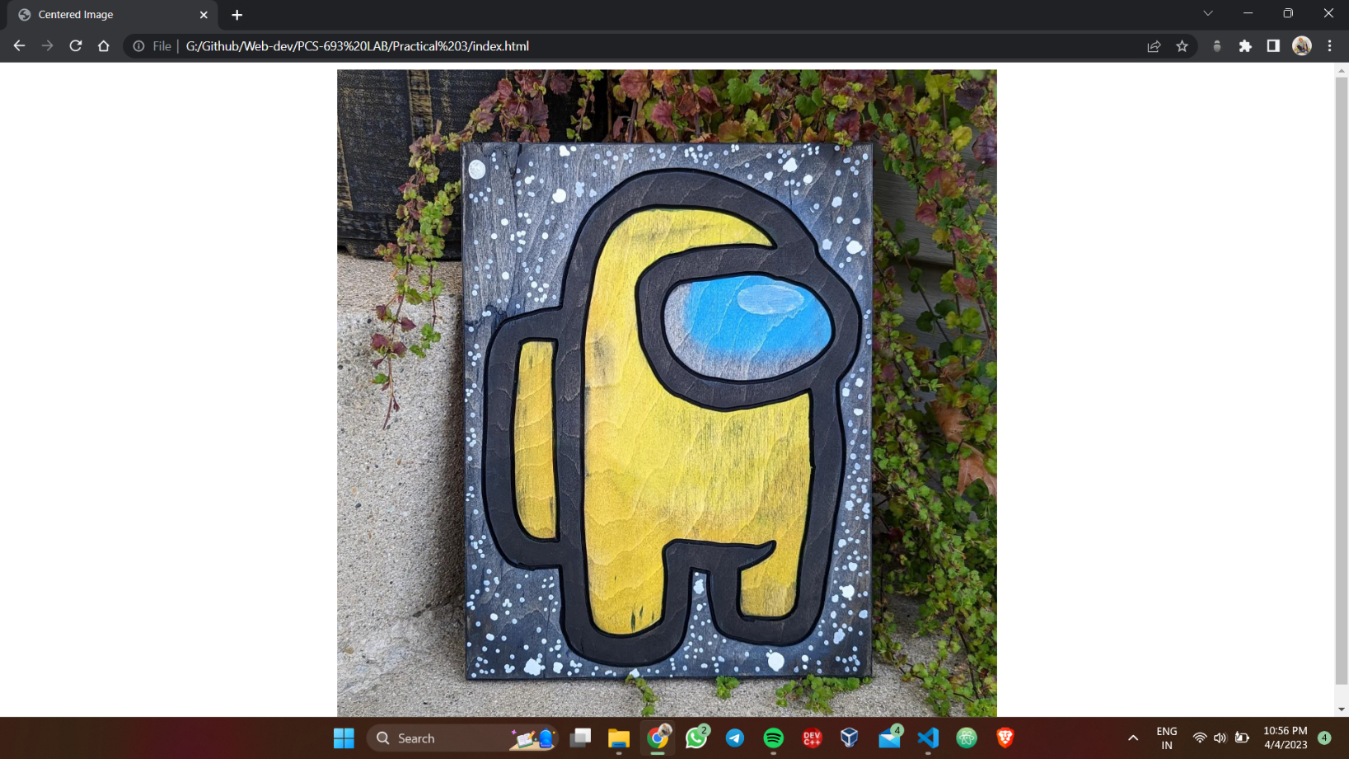

**Practical 4**

**4. Create web Pages using Anchor tag with its attributes for external links.**

<!DOCTYPE>

<html lang="en">

<head>

<title>Anchors</title>

</head>

<body>

<h2><a href="https://www.google.com/" target="_blank">Google</a></h2>

</body>

</html>

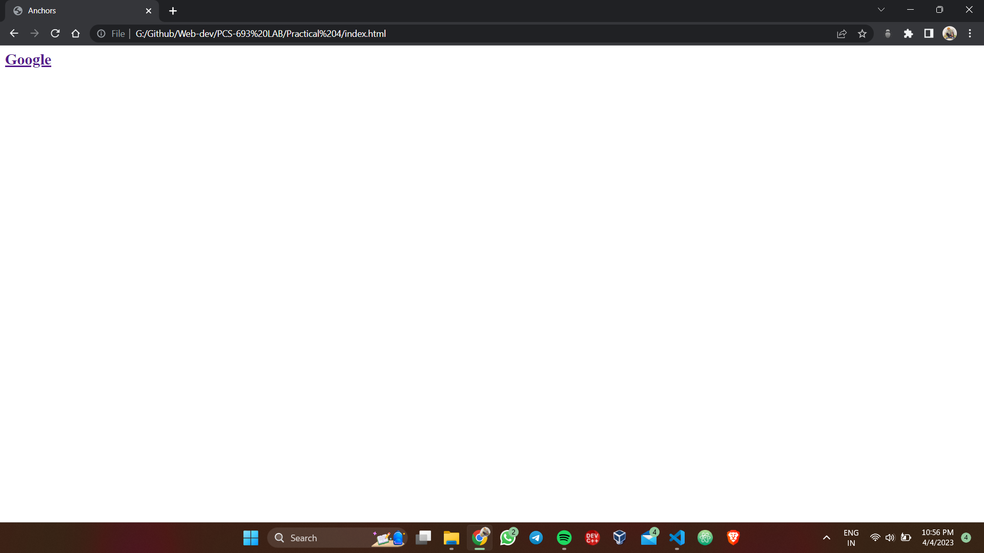**Output**

**Practical 5**

**5. Write a HTML code to create a web page with pink color background and display moving message in red color.**

<!DOCTYPE html>

<html lang="en">

<head>

<title>Moving Text</title>

</head>

<body style="background-color: pink;">

<marquee direction="right" style="color: red;">This is a special tag</marquee>

</body>

</html>

**Output**

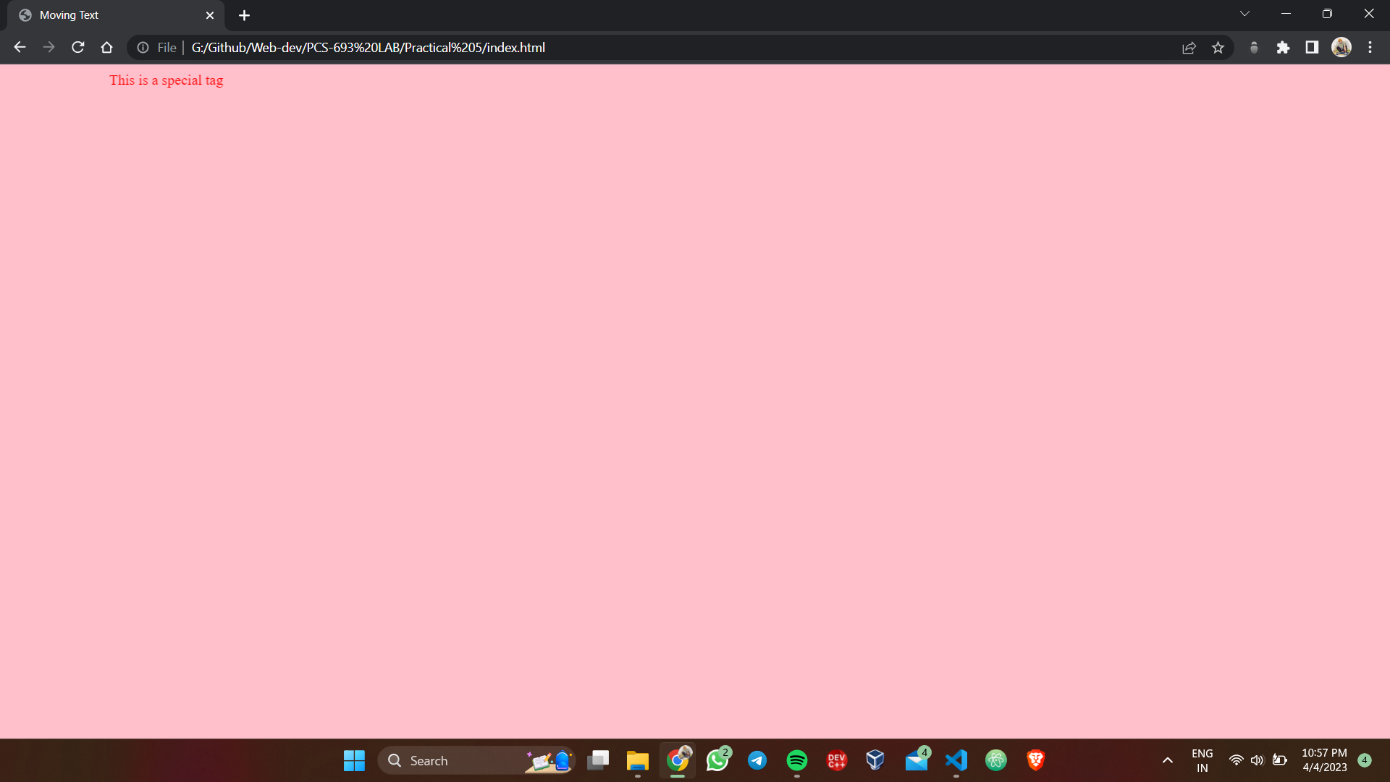

**Practical 6**

**6. Create a web page, showing an ordered list of all second semester courses.**

<!DOCTYPE html>

<html lang="en">

<head>

<title>Ordered lists</title>

</head>

<body>

<h3>Second Semester Courses</h3>

<ol type="I">

<li>Compiler Design</li>

<li>Computer Network</li>

<li>Full Stack Web Development</li>

<li>Image Processing</li>

<li>Career Skills</li>

<li>Software Engineering</li>

</ol>

</body>

</html>

**Output**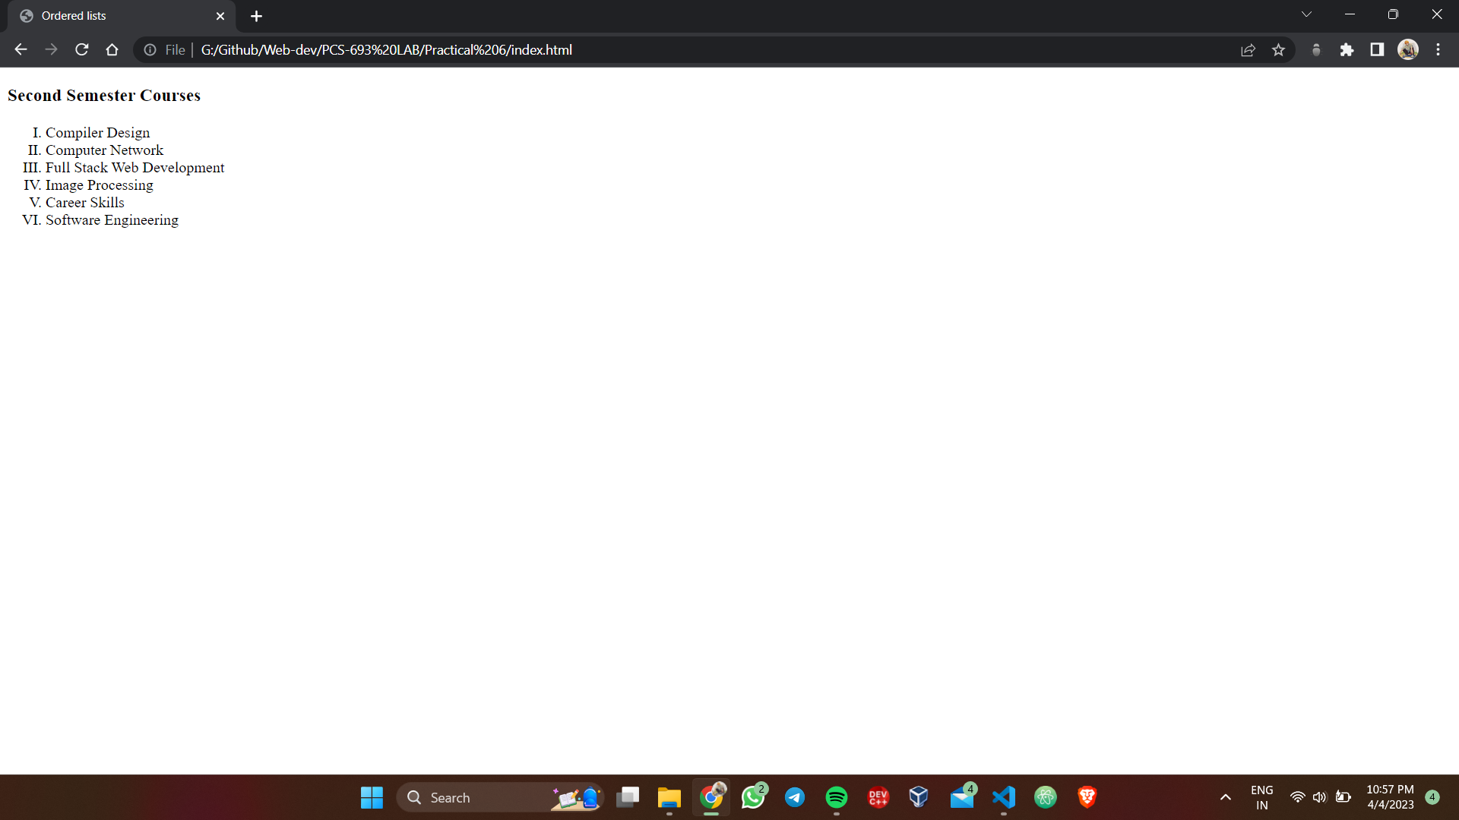

**Practical 7**

**7. Create the following table in HTML with Dummy Data.**

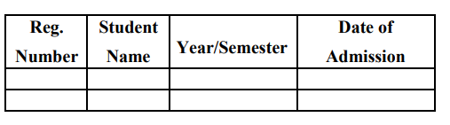

<!DOCTYPE html>

<html lang="en">

<head>

<title>Dumpy Table</title>

</head>

<style>

table,th,td {

border: 2px solid black;

border-collapse: collapse;

}

</style>

<body>

<table style="width: 400px;">

<tr>

<th>Reg. Number</th>

<th>Student Name</th>

<th>Year/Semester</th>

<th>Date of Addmision</th>

</tr>

<tr>

<td>001</td>

<td>Rancho</td>

<td>third</td>

<td>2-08-2008</td>

</tr>

<tr>

<td>002</td>

<td>Raju</td>

<td>six</td>

<td>15-08-2008</td>

</tr>

</table>

</body>

</html>

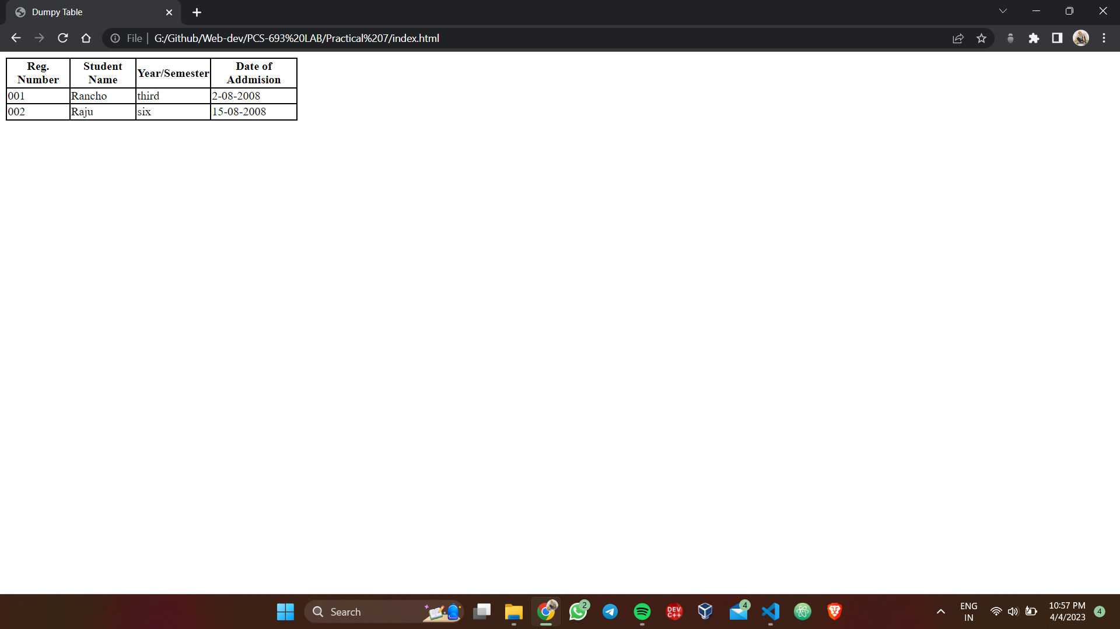**Output**

**Practical 8**

**8. Create a web page which divides the page in two equal frames and place the audio and video clips in frame-1 and frame-2 respectively.**



<!DOCTYPE html>

<html lang="en">

<head>

<title>Frames</title>

</head>

<frameset cols="50%,50%">

<frame src="frame1.html" name="Frame1">

<frame src="frame2.html" name="Frame2">

</frameset>

</html>

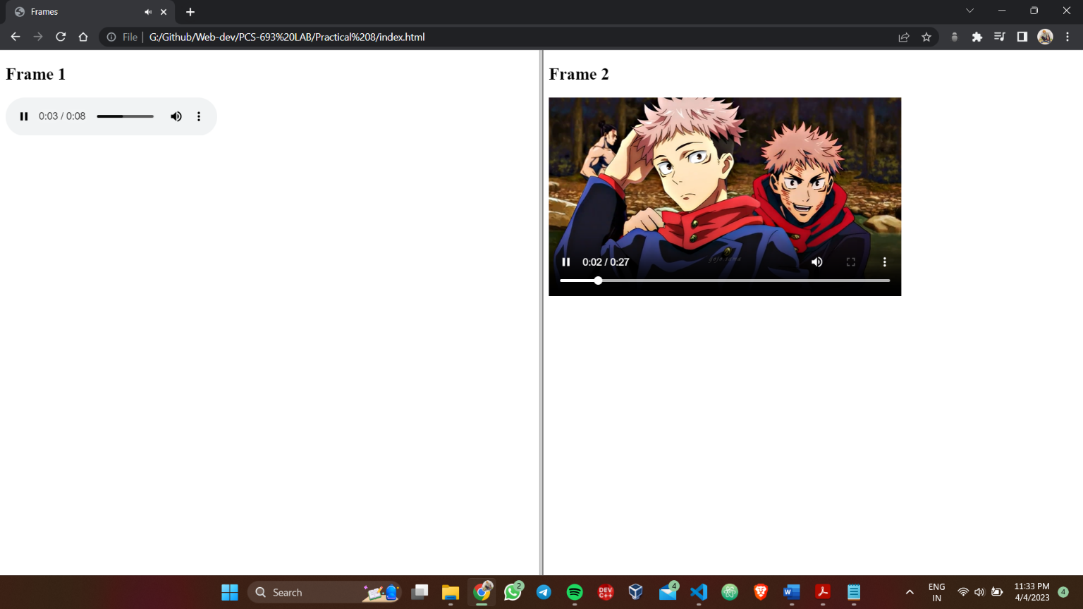**Output**